**Antique Gold Small Ornate Mirror**

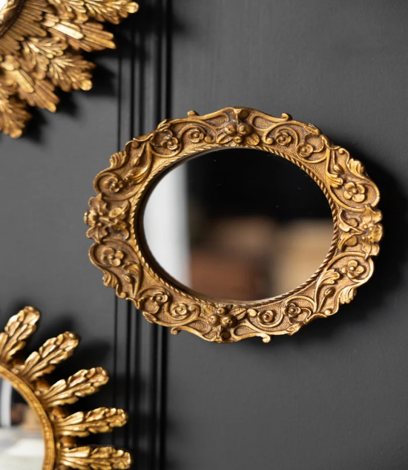 The antique gold small ornate mirror exudes timeless elegance and vintage charm, featuring intricate detailing and a warm, golden finish. Its ornate frame, often adorned with delicate scrollwork and floral motifs, adds a touch of sophistication to any room. Perfect for smaller spaces or as an accent piece, this mirror not only serves a functional purpose but also acts as a statement decor element. The antique gold hue lends a sense of luxury and nostalgia, making it ideal for traditional, vintage, or even eclectic interiors. Whether hung in a hallway, bathroom, or living room, it brings a refined, classic aesthetic that enhances the overall ambiance.